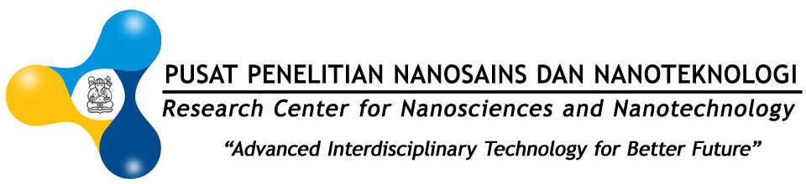

SCHEDULE BERKELEY EMERGING RESEARCH SCHOLAR
WORKSHOP ON METAL ORGANIC FRAMEWORK (MOFs):
Definitions, Synthesis Characterizations and Its Application

Research Center for Nanosains and Nanotechnology (RCNN)

Center for Advanced Sciences (CAS) Building 3rd Floor

Institut Teknologi Bandung

Jl. Ganesha No.10, Bandung

THURSDAY, 23 NOVEMBER 2017
TIME | AGENDA | SPEAKERS
13.00 - 14.30 | Introduction to Reticular Chemistry (History, Practical Theory, Topology) | Kyle Cordova | Meeting Room, CAS Building, 3rd Floor
14.30 - 14.45 | COFFEE BREAK
14.45 - 16.15 | Synthesis and Characterization of Reticular Materials (Synthetic Techniques, Strategies, and Basic Characterization) | Kyle Cordova
FRIDAY, 24 NOVEMBER 2017
08.00 - 09.00 | Post-Synthetic Modification (Functionalization of Reticular Materials) | Kyle Cordova | Meeting Room, CAS Building, 3rd Floor
09.00 – 09.15 | COFFEE BREAK
09.15 - 11.00 | MOF Characterization (Characterization Techniques and Porosity) | Kyle Cordova
11.00 - 13.00 | ISHOMA
13.00 - 14.30 | Computational Modeling and Structural Solution from X-ray Diffraction (Part 1) | Ha Lac Nguyen
14.30 - 14.45 | COFFEE BREAK
14.45 - 16.15 | Research Discussion + Lab Work (as needed) with Students | Kyle + Ha
SATURDAY, 25 NOVEMBER 2017
09.00 - 10.30 | Computational Modeling and Structural Solution from X-ray Diffraction (Part 2) | Ha Lac Nguyen | Meeting Room, CAS Building, 3rd Floor
10.30 - 10.45 | COFFEE BREAK
10.45 - 12.00 | Topological Analysis (RCSR Database, TOPOS) | Ha Lac Nguyen

MONDAY, 27 NOVEMBER 2017
TIME | AGENDA | SPEAKERS
09.00 – 10.30 | Applications in Gas Capture and Storage for Reticular Materials (CO2 capture, H2 storage, CH4 storage) | Ha Lac Nguyen | Meeting Room, CAS Building, 3rd Floor
10.30 - 10.45 | COFFEE BREAK
10.45 - 12.15 | Global Science: Capturing the Human Potential | Kyle Cordova

INSTITUT TEKNOLOGI BANDUNG – INDONESIA
Jl. Ganesha No. 10, Bandung, West Java - Indonesia

